Terms of Reference for consultancy service of
Urban Designers

Introduction
Well-designed streets are a critical element of a safe and efficient mobility system. At present, [CITY] is facing the challenges of increased congestion, pollution, and road safety risks. Going forward, the IMPLEMENTING AGENCY (IMPLEMENTING AGENCY) seeks to address these issues by establishing a network of streets that offer convenience and safety to all users.
The IMPLEMENTING AGENCY (IMPLEMENTING AGENCY) (hereinafter “Client”) seeks to appoint a firm (hereinafter “Consultant”) to prepare detailed designs for pedestrian improvements along the ________Street to improve comfort, safety, and convenience for all street users.

Objectives
The main objectives of the study are as follows:
- To provide better facilities for sustainable modes such as walking, cycling, and public transport.
- To employ a holistic approach to street design, incorporating mobility elements—e.g. footpaths, cycle tracks, carriageways—as well as additional elements such as trees, bus stops, street furniture and organised vending spaces in an integrated design.
- To ensure that street design is based on scientific assessment of needs and behaviour of street users, as observed in the surveys as part of this study.
- To ease road congestion through improved intersection design and more efficient use of the existing public right-of-way in lieu of major capacity additions.
- To employ traffic calming measures to ensure pedestrian safety on all streets.
- To ensure that all spaces, including footpaths, refuge islands, and pedestrian crossings, are accessible to differently abled persons as per the Persons with Disabilities Act of 1995. To improve access for persons with disabilities, the designs should employ at-grade crossings rather than foot over bridges and subways.

Scope of Work
The Scope of Work includes:
- Definition of study area
- Survey of land uses
- Survey of pedestrian facilities
- Survey of pedestrian movements
- Survey of street vending and related activities
- Preparation of detailed street designs
- Bill of quantities

Approach Methodology

Step 1: Definition of study area
The Study Area comprises a stretch of approximately 260 m along ______ Street, from ______ Road to ______ Street (Figure 1).
Insert map
Figure 1: Study area indicating pedestrian zone and footpath upgrade on ______ Street.

Step 2: Survey of land uses
The Consultant will compile land use information to help inform street design decisions. A land use survey must be carried out for every building adjoining Study Area streets. In cases where the ground floor use is different from that of rest of the floors, the surveyors should make a note. The number of floors per structure also must be noted. Important activity generators adjacent to all Study Area streets, such as shopping areas, theatres, and housing developments, should be identified. All land use data should be recorded using the GIS platform.

Step 3: Survey of pedestrian facilities
The Consultant will document the quality of existing pedestrian facilities on all streets in the Study Area, noting properties such as the clear width of the footpath on each side every 50 m (if present), the number of obstructions per km in the clear width, and the presence of shade at 2 p.m. (from buildings or trees). These data should be stored and mapped using the GIS platform. The Consultant will also take photos of the Study Area for use in before-and-after comparisons of the project intervention.

Step 4: Survey of pedestrian movements
Surveys shall be carried out to assess non-motorised transport (NMT) user flows at important locations in the study area. The survey shall be from 06:00 to 22:00 on a normal working day. The Consultant will record the number of pedestrians and cyclists moving along ________Street; and conduct a tracking survey of pedestrian crossing movements at important intersections including ________Street, ________Street and ________Street intersection. The actual pedestrian movement lines should be mapped as in the example shown in Figure 2.
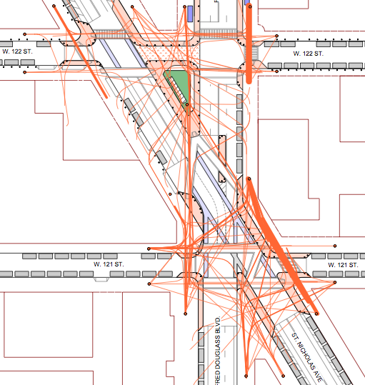
Figure 2. Example of a tracking survey diagram. The orange lines represent pedestrian movements. Thicker lines indicate higher pedestrian volumes.

Step 5: Survey of street vending and related activities
The surveyor must make note of all the vendors in the Study Area. The survey should note the type of vending and the physical typology of the vending structure (i.e. permanent or temporary structure). The survey should also note whether the vendor is an obstruction to pedestrian and cycle movement. The location and characteristics of each vendor should be recorded using GIS. The survey also should capture social gathering spaces and other activities found in the public ROW in the study area. The location and number of people engaged in the activities should be noted using GIS. This information will inform the placement of street furniture and other elements in the final design.

Step 6: Preparation of detailed street designs

Conceptual designs
The Consultant shall prepare detailed street designs for _______ Street. The designs shall be prepared following relevant Indian Roads Congress standards, especially IRC 103:2012, Guidelines for Pedestrian Facilities. The Consultant should also refer to street design manuals such as Better Streets, Better Cities: A Guide to Street Design in Urban India by the Institute for Transportation and Development Policy, the Street Design Guidelines prepared by UTTIPEC, and Tender Sure: Specifications for Urban Roads Execution, written by Bangalore City Connect and the India Urban Space Foundation.
The design should be based on the conceptual plan displayed in Figure 3. The stretch from _______ Road to _______ Street should incorporate wide footpaths on both sides of the road. The second stretch, from _______ Street to _______ Street, should be designed as an exclusive zone for pedestrians with cycle access.
Insert map
Figure 3 Conceptual plan for ________Street

The pedestrian zone should incorporate the following elements:
- Special paving material to clearly indicate street for pedestrians only
- Flat walking surface without abrupt level differences
- Location of landscaping dependent on survey of pedestrian movements and street vending.
- Integrated landscaping plans to ensure continuous shade.
- Street furniture located under shade.
- Adequate lighting provided at regular intervals.
- Pedestrian zone signage located at both ends of the street.
- Physical elements to discourage motor vehicle access to the zone while maintaining convenient, universal access for pedestrians as well as access for cycles.
The pedestrian footpaths should meet the following standards (Figure 4):
- A minimum of 2 m wide clear pedestrian zone
- A height of no more than 150 mm
- Flat walking surface without abrupt level differences
- Continuous walking path
- Integrated with landscaping plan to ensure continuous shade
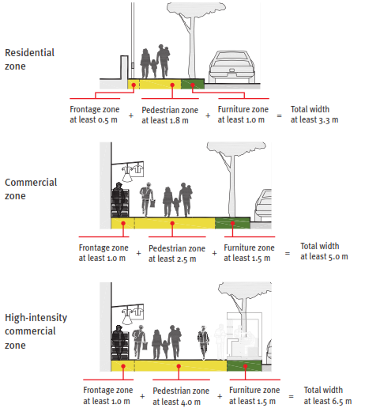
Figure 4 Details of footpath zones according to land use activities
The street designs should include but are not limited to the following elements:
- Dedicated pedestrian footpaths.
- Pedestrian crossings, including formal speed table crossings as well as median breaks that serve as informal crossing locations.
- Trees to provide shade for pedestrians and cyclists as well as decorative landscaping, including compensatory afforestation for the trees removed as part of the project.
- Spaces for street vending.
- Medians.
- Traffic calming elements, where needed to reduce vehicle speeds.
- Street furniture, including benches, stools, tables, and other seating arrangements.
- Signage locations.
- Pedestrian refuge islands.
- Carriageways, ensuring that the width remains uniform between intersections.
- Street lighting.
- Storm water drains.
- Utility access points.
Intersection designs should promote pedestrian safety through elements such as pedestrian refuge islands, reduced angles of approach, reduced turning radii, and traffic calming. The design of pedestrian crossings at intersections and in mid-block locations should ensure that pedestrians do not need to cross more than 2 lanes (6 m) at a time.
The Consultant will submit a plan drawing as well as cross sections at every 50 m. The plans will be submitted in hard copy and electronic format. The Consultant must prepare at least three photorealistic 3D renderings and/or photomontages representing the design proposal.

Review of Conceptual Designs
The designs will be evaluated by a Review Committee (see below) before preparing the final working drawings. The Consultant may be asked to present the designs to the Review Committee.
The Consultant may be required to present the plans at a public stakeholder meeting.

Revised Conceptual Designs
The Consultant will prepare Revised Conceptual Designs based on the feedback received from the Review Committee and stakeholders. The Revised Conceptual Design must be submitted to the Client for approval.

Draft working drawings
Following approval by the Client of the conceptual designs, the Consultant will prepare detailed construction drawings for the Study Area. The designs should include geometric and vertical profiles and should incorporate drainage designs (see below). The designs should include the following components:
- Typical sections at every 25 m.
- Street plan.
- List of existing street elements to be demolished.
- Utility relocation plans (wherever necessary).
- Materials as per Client specifications.
- Construction details for each element.
The Draft Working Drawings must be submitted to the Client for approval.

Final Working Drawings
The Consultant will prepare Final Working Drawings based on the feedback received from the Client. The Final Working Drawings must be submitted to the Client for approval.
The Consultant will submit all conceptual designs and final working drawings to the Client in hard copy and electronic format.

Step 8: Bill of quantities
The Consultant is expected to prepare specifications, bills of quantities, cost estimates, and bid documents for the implementation of the proposed street improvements, including pavements, furniture, street lighting, landscaping and other components. Bid documents shall be given item-wise (i.e. streets, lighting, landscaping, road markings, etc.). The Consultant will work with the Client to include appropriate mechanisms in the bid documents to facilitate long-term maintenance, such as annuity-based compensation of contractors.

Working Modalities

Presence in [CITY]
The Consultant will be expected to have a local office in the same city as the proposed projects. Outstations consultants are required to set up a field office in the city or alternatively collaborate with a local architectural firm.

Payment structure
The payment schedule for the Consultants service will be structured as presented in Table 1.

Table 1. Payment schedule
- Consultant output | - Payment (% of total service fee)
- Mobilisation fund | - 5
- Inception report and survey results | - 10
- Conceptual Designs | - 20
- Consultation with review committee; revised conceptual design and draft working drawings | - 20
- Final Working Drawings and Plans | - 30
- Implementation monitoring | - 10
- Post implementation | - 5

The Consultant may be required to attend several meetings leading up to the implementation of the proposal. The cost of attending meetings will be borne by the Consultant. Once these requirements are met, the Client will make payments as per the above structure to the Consultant.

Review Committee
The Review Committee will consist of following
- City Engineer, from Respective ULBs
- Zonal Officer, from Corporation
- Representative from District Collectorate
- Representative from Police (Traffic)
- Representative from Local Planning Authority
- Representative from ITDP
The review committee will review the conceptual street designs. The comments or views on the various submissions shall be given to the Consultant within 15 days of submission.

Timeline
Table 2 Timeline of project
- Consultant output | - Description | - Deadline
Inception Report | Study area and description of all data collection activities (including survey forms). | 7 days after signing of contract
Survey Results | Raw data, analysis, and mapping of findings from: analysis of topographic survey; survey of land uses and activities; survey of pedestrian facilities; traffic surveys. | 14 days after approval of Inception Report
Conceptual Designs | Conceptual designs for all street elements in the Study Area. | 21 days after approval of Survey Results
Consultation with Review Committee | Preparation of presentation and hard copy drawings showing the Conceptual Designs. | Within 5 days of submission of Conceptual Designs
Revised Conceptual Designs | Revision of the Conceptual Designs based on feedback from the Review Committee. | 7 days after receipt of comments from Review Committee members
Draft Working Drawings | Typical sections along various segments, horizontal control plan, demolition plan, utility relocation plans, material specifications, construction details for each element. Bill of quantities. | 14 days after Client approval of the Revised Conceptual Designs
Final Working Drawings and Plans | Revisions incorporating feedback from the Client on the Draft Working Drawings. | 15 days after receipt of Client comments on the Draft Working Drawings
Implementation monitoring | On-site monitoring of construction accuracy. Site supervision and coordination | Up to the end of execution on site
Post implementation | Resolving of design issues post execution (if any). Documenting of street condition, before and after implementation (photographs). | Up to a duration of 3 months

Bidding process

Eligibility requirements
The Consultant team must include a Project lead who has at least 5 years of experience in urban design (or equivalent) and is expected to be familiar with NMT user needs, street design principles, street design standards, geometric design of streets, and traffic calming. The Project Lead should be registered with the Council of Architecture (proof to be submitted) and with the Institute of Urban Designers, India (proof to be submitted).
Consortiums are eligible to apply.

Eligibility criteria

Skill requirements
The qualifications of the Consultant’s team members will be reviewed as part of the evaluation process. The key professionals listed in Table 3 are to be engaged by the Consultant along with support staff and specialists with adequate experience to ensure that the objectives of the project are achieved within the specified timelines. The CVs of the professionals listed in Table 3 will be reviewed as part of the evaluation.

Table 3: Required qualifications of Consultant team members
- Specialisation | Requirement | Team members required
Project Lead | The project lead shall have a Masters Degree in Urban Design, Architecture, landscape Architecture or an equivalent degree. S/he shall have at least 5 years of experience in urban design (or equivalent) and is expected to be familiar with NMT user needs, street design principles, street design standards, geometric design of streets, and traffic calming. International experience shall be treated as merit. | 1
Architect | Degree in Architecture or equivalent field with at least 3 years of experience. | 2

The above team should be supported by adequate support staffs and other experts / specialists with adequate experience to ensure that the objectives of the project are achieved within the time lines.

Experience and methodology
The evaluation will depend on the applicant’s experience and familiarity with street design, especially the design of NMT facilities. Expected areas of experience include:
- Successful completion of similar street design services in India involving the design of streets, public spaces, transport facilities (especially walking and cycling facilities) and amenities;
- Familiarity with NMT user needs, street design principles, street design standards, geometric design of streets, and traffic calming;
- International experience in urban design and/or similar street design project.

Scoring system
Table 4 indicates the criteria for the technical scoring of applicants. Applicants must receive a minimum score of 60 in order to be eligible to bid.
Table 4. Scoring criteria
 | Possible score
Methodology and experience
Approach and methodology | 40
Experience with similar street design projects | 15
Number of projects of similar scale designed to date | 15
Number of street design projects executed for government authorities | 5
Team
Project Lead (relevant experience and qualifications in urban design/street design) | 15
Architect/Landscape Architect (with relevance experience and qualifications) | 7
Awards for public space design or street design | 3
Total technical score | 100

Submission of proposal
The submission envelope must be clearly marked with the following text: “Consulting Services for Pedestrian Zone Design for the IMPLEMENTING AGENCY.” The Consultant should include two separate envelopes in the main submission envelope: one containing the Technical Bid and another with the Financial Bid. The sub-envelopes must be marked with the project name and the type of bid. The Technical Bid envelope should contain the following information:
- Name, address, and contact details of the Project Lead.
- Company profile.
- List of technical staff employed full time with the applicant (part time staff shall not be considered).
- Detailed CVs of the technical staff.
- Proof of professional affiliations of staff.
- List of staff and facilities (office space, computers, software, printers/scanners etc.) available with the firm for performing the activities of the TOR, including an indication of which facilities are available in the [CITY] metropolitan area and other cities in _________state.
- Description of approach and methodology for the current TOR.
- Portfolio of previous works.
Applicants will be requested to make presentation to the Client indicating the following:
- Experience with similar street design projects.
- Proposed approach and methodology for the selected street.
The Financial Bid envelope should include the Consultant’s monetary bid for the project.
Applicants shall submit all materials before date mentioned in the notice.

Financial proposal
Financial Bids of applicants with a total Technical Bid score of 60 and above shall only be opened. For Consultants who do not qualify per the Technical Bid, the Financial Bids shall be returned unopened.
The score for each Financial Proposal, F, will be computed as follows:
F = 100 × F_{m} / F_{c}
where F_{m} is the total price of the lowest Financial Proposal and F_{c} is the total price of the Financial Proposal under consideration.

Combined evaluation of technical and financial bids
The Client reserves the right to reject, at its sole discretion, any or all evaluated Financial Proposals and if necessary, call for submission of new Financial Proposals. In order to allow comparison on a common basis, each proposal will be carefully scrutinised in accordance with the procedure outlined above and technically eligible proposals will be scored on the basis of following formula:
Score = 0.60 T + 0.40 F
where T is technical score and F is financial score. The Bidder with the highest Score will be selected.

Annexure I

Package Details
Street name | From | To | Length (m) | Width (m) | Project

<http://uttipec.nic.in/writereaddata/linkimages/7554441800.pdf>, <http://www.itdp.org/betterstreets>, <http://indiausp.org/?q=node/298>

